Online Counselling & Therapy
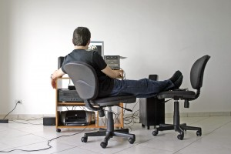
Do you live in the Peace Region? Online Counseling through Peace of Mind Counselling & Therapy – is available for you.
Whether you’re traveling, feeling under the weather, or pressed for time and money, I understand that it’s not always easy to get Peace River at the best of times. I also understand that privacy and confidentiality are important. Now you can get high-quality client centered counselling in the convenience of your home or any other convenient private location.
Peace of Mind offers you a convenient alternative to coming into our office. You can now visit your counselor online and get the same client-focused care that you would receive at thee Peace of Mind cottage.
HOW IT WORKS
It’s simple. After completing your initial office session, and completing the required forms you can opt for future online sessions via Zoom. Together we will set up a time and I will send you a Zoom invitation and reach you by computer or phone.
I recommend that you choose a location that’s private and away from any distractions to have your virtual session. Headphones do enhance sessions and are recommended.
Please check your health benefits coverage to determine that it covers telehealth from your location. Online E transfer is accepted for payment and sometimes through preapproval on certain benefits plans.
Please call or text me with any questions about Peace of Mind Counselling & Therapy.

